<https://preppindata.blogspot.com/2019/12/2019-week-45.html>

Note: Case study requ is not clear and output /solution images are not visible so not able to interpret it.

I designed the solution with below assumption:

1. Remove duplicates
2. For first output – Calculate total sales store wise and then individual Scent % contribution

Actual requirement :

Data is everywhere and often in annoyingly small files that we need to piece together before we can begin analysis; Chin & Beard Suds Co is no different.  
  
This week's challenge is to piece together data we have received from our Clapham and Wimbledon stores. We've heard there are lots of differences between our two stores in South West London for Sales Volumes and Values. We've heard there are duplicates in the dataset so help us remove these as the entries are the same, just doubled up due to some reporting issues.

### Requirements

[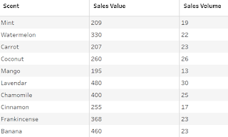](https://1.bp.blogspot.com/-Yd8qyk2uq-Y/XflTR5jfhsI/AAAAAAAAAww/PDm4OK2yubkibYrYAe4PaYkfqJoE7XYVwCEwYBhgL/s1600/Screenshot%2B2019-12-17%2Bat%2B22.05.05.png)

* [Input all Data Files](https://drive.google.com/open?id=1QtYw2MT1d8uYKHcUS_QY6dwvvXg76eme)
* Remove Duplicates (identical rows)
* Work out the percentage of:
  + Scent sales per Store's Total Sales Values and Volumes
  + Weekday sales per Store Total Sales Values and Volumes
* Replace Weekday with full date
* Output Data

### Output

Two Files:

[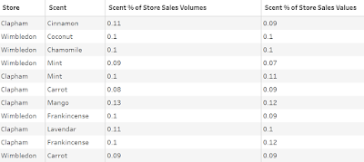](https://1.bp.blogspot.com/-wJ0nu_AMqsE/XflTR3eHblI/AAAAAAAAAws/SH7JDCTifV0nPIOw7bKQdxWLjLf_JXNjwCEwYBhgL/s1600/Screenshot%2B2019-12-17%2Bat%2B22.04.11.png)

1. Scent

- 20 rows (21 rows including headers)

- 4 columns:

* Store
* Date
* Scent % of Store Sales Volumes
* Scent % of Store Sales Values

[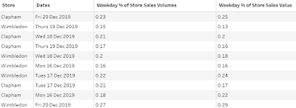](https://1.bp.blogspot.com/-AvzQXU8PHTg/XflTR8WuvjI/AAAAAAAAAwo/cqINt17ncbwvf2gfOtOyNY9HBOXliFT_ACEwYBhgL/s1600/Screenshot%2B2019-12-17%2Bat%2B22.04.31.png)

2. Weekday

- 10 rows (11 rows including headers)

- 4 columns:

* Store
* Date
* Weekday % of Store Sales Volumes
* Weekday % of Store Sales Values